**FACULTY OF COMPUTING AND INFORMATICS**

**CGD6334-GAME PHYSICS**

**TRIMESTER 2 2024/25**

**PROJECT #1**

**Report**

**Lecture Section: TC1L**

**Tutorial Section: TT1L**

**From:**

|  |  |  |
| --- | --- | --- |
| **Student ID** | **Name** | **Email Address** |
| **1201100503** | **Low Yong Zhi** | **1201100503@student.mmu.edu.my** |
| **1201100622** | **Lim Wei Pang** | **1201100622@student.mmu.edu.my** |

**Acknowledgement**

We would like to express our special thanks of gratitude to Dr Wong Ya Ping for giving us the opportunity to this project and providing invaluable information and knowledge to help successfully complete the project. His guidance and advice greatly helped our understanding and execution for this project.

Special thanks are also to the collaborative efforts of the team member, Lim Wei Pang. The dedication, teamwork, and collective contribution were instrumental in bringing this project to fruition. Each member's unique skills and commitment enriched the collaborative experience, resulting in a project we are proud to present.

We would also like to extend our sincere gratitude to MMU (Multimedia University) for granting us the privilege to pursue our academic journey and participate in impactful projects. The support from the university, in terms of both comprehensive courses and a nurturing academic environment, has played a pivotal role in our academic and project endeavors. We are grateful for the invaluable experiences and knowledge acquired throughout our tenure at MMU.

**Introduction / Problem Statement**

Welcome to Bounce Bullet, an exciting and thrilling game where you step into the shoes of a brave hunter on a mission to vanquish evil ghosts haunting the land. Armed with your trusty bazooka, you must navigate through challenging levels, strategically shoot bouncing bullets, and eliminate all ghostly threats.

**Documentations of Game**

**Physics Integration**

**Gravity**

Gravity in the game world ensures that the player and enemies stay grounded on platforms. It affects their vertical movement, making them fall unless supported by a platform.

Implementation Details:

* Setting Global Gravity: Gravity is applied globally in the physics world, ensuring all objects are affected unless specified otherwise.
* Player Gravity: The player sprite has gravity applied to it, which keeps it grounded on platforms.
* Enemy Gravity: Enemies also have gravity, making them fall onto and stay on platforms.

**Bounce**

Bounce mechanics make interactions with surfaces more dynamic. Bullets bounce off platforms and other surfaces, allowing strategic shots to reach enemies in difficult positions.

Implementation Details:

* Bullet Bounce: Bullets bounce off platforms with a defined elasticity, losing a bit of energy on each bounce.
* Bounce Count: Each bullet is allowed a maximum of five bounces before being destroyed.
* Bounce Sound: A sound effect is played each time a bullet bounces off a surface. -scene and gameplay flow.

**Scene and Gameplay Flow**

The game consists of multiple scenes that guide the player through the game, from starting the game to playing different levels.

**Start Scene**

* Title Text: Shows the game title "Bounce Bullet"
* Start Button: Presents a button labeled "Start." Clicking this button transitions the player to the ChooseLevelScene.

**Choose Level Scene**

* Level Buttons: Displays buttons for Level 1, Level 2, and Level 3.
* Each button highlights when hovered over and starts the respective level scene upon clicking.

**Gameplay Scene (e.g., Level 1)**

**Player (Hunter)**

* Adds a player sprite with physics properties such as gravity and collision.
* Allows the player to control the angle of the weapon using arrow keys.

**Enemies (Ghost)**

* Adds multiple enemy sprites with physics properties.
* Places enemies on platforms strategically.

**Weapon and Bullets**

* Adds a weapon sprite and a group of bullets.
* Limits bullets to 5 per level.
* Fires bullets on mouse click.

**Controls**

* Arrow keys to adjust the weapon's angle.
* Mouse click to shoot bullets.

**Collisions**

* Handles bullet-platform collisions, making bullets bounce (Maximum 5 times).
* Handles bullet-enemy collisions, destroying enemies upon impact.

**Game End Conditions**

* Displays "You Win" if all enemies are destroyed.
* Displays "You Lose" if the player runs out of bullets with remaining enemies.

**Score Display**

* 10 marks for each Ghost.
* 100 marks for each left bullets.

**Audio Elements**

* Background music when the game start.
* Sound effect when bullet bouncing with the wall.
* Sound effect when the ghost die.

**User Guide / Instructions and Screen Shots**

**Game Set Up:**

1. Download the game zip folder and extract it.
2. Download Visual Studio Code
3. Prepare Phaser JS and Live Server Extension

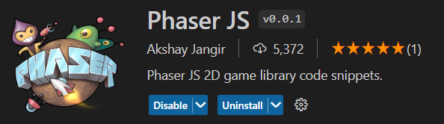



1. Open folder in visual studio code.
2. Open the game.js in visual studio code.
3. Run the program by triggering the “Go Live” button.



1. The game will opened in the browser.

**Game Control:**

1. Start Menu

* Click the button “Start” to initiate choose level scene.

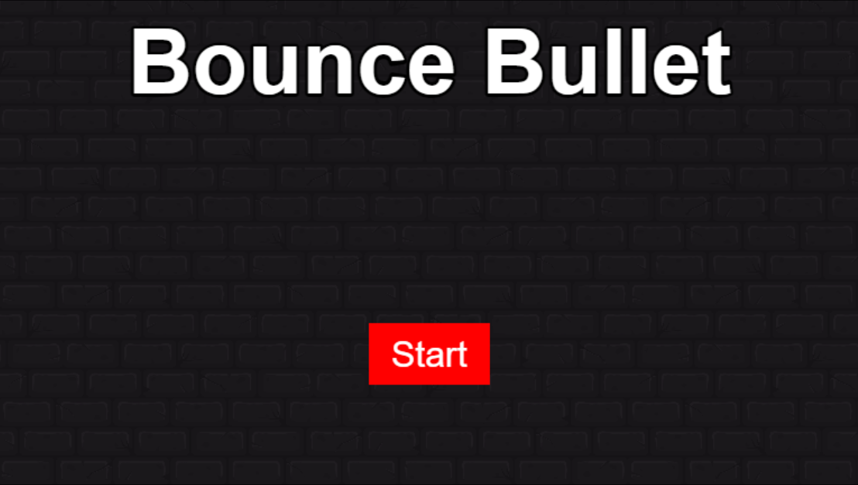

1. Choose Level Scene

* Click the “Level” button to initiate the gameplay scene.

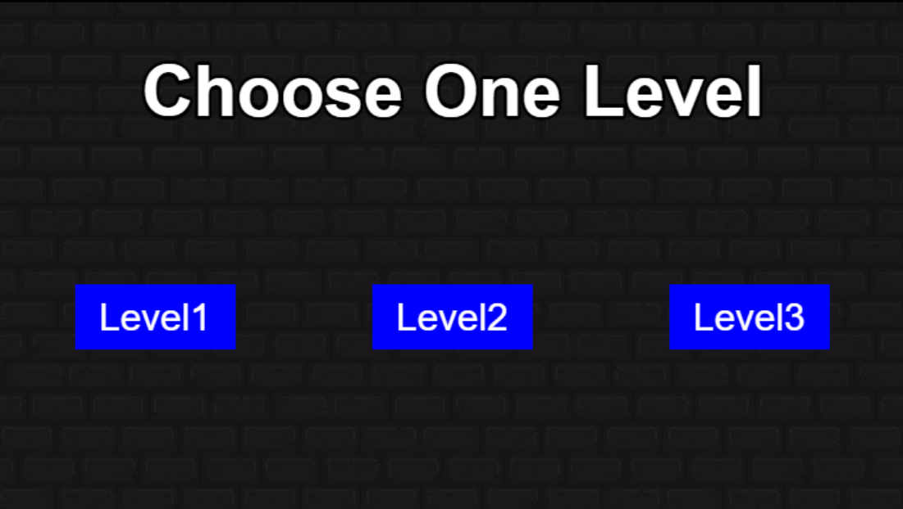

1. Level1

* Players need to shoot at different angles without move to make the bullets bounce back until they hit the enemy.
* Click up “arrow key and down arrow key” to adjust the direction of the bazooka.
* Click the “left mouse button” to fire the bullets.

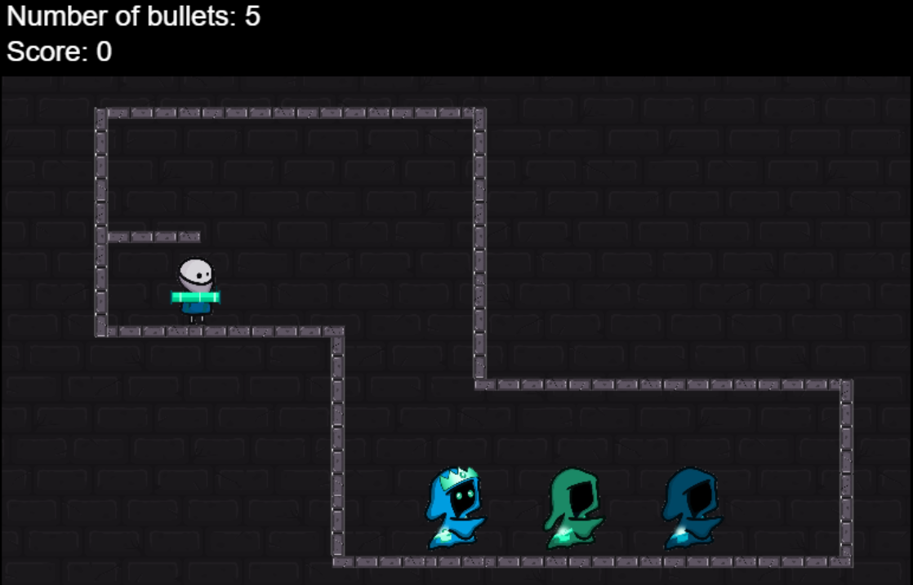

1. Level2

* Players need to shoot at different angles without move to make the bullets bounce back until they hit the enemy.
* Click up arrow key and down arrow key to adjust the direction of the bazooka.
* Click the left mouse button to fire the bullets.

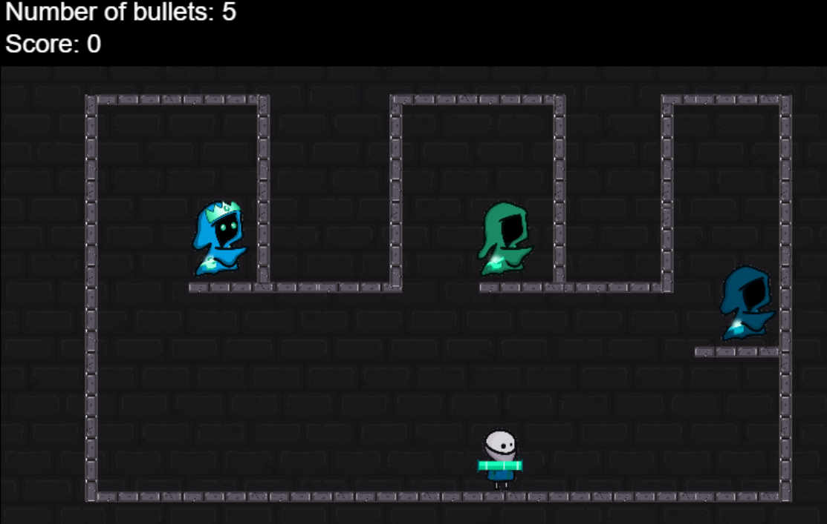

1. Level3

* Players need to shoot at different angles without move to make the bullets bounce back until they hit the enemy.
* Click up arrow key and down arrow key to adjust the direction of the bazooka.
* Click the left mouse button to fire the bullets.

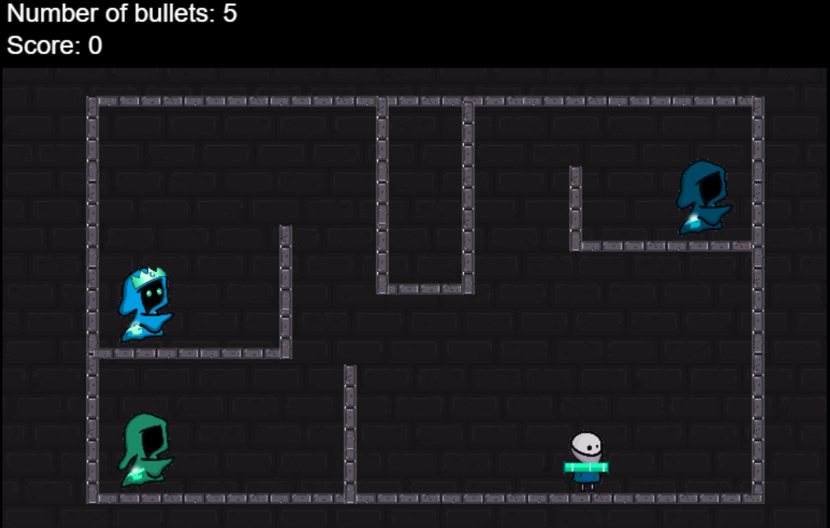

1. Win/Lose Scene

* If you defeat the entire enemy in five amount bullets, then you win the game.
* Choose “Restart” if you want to play again.
* Choose “Main Page” to get back to start scene.

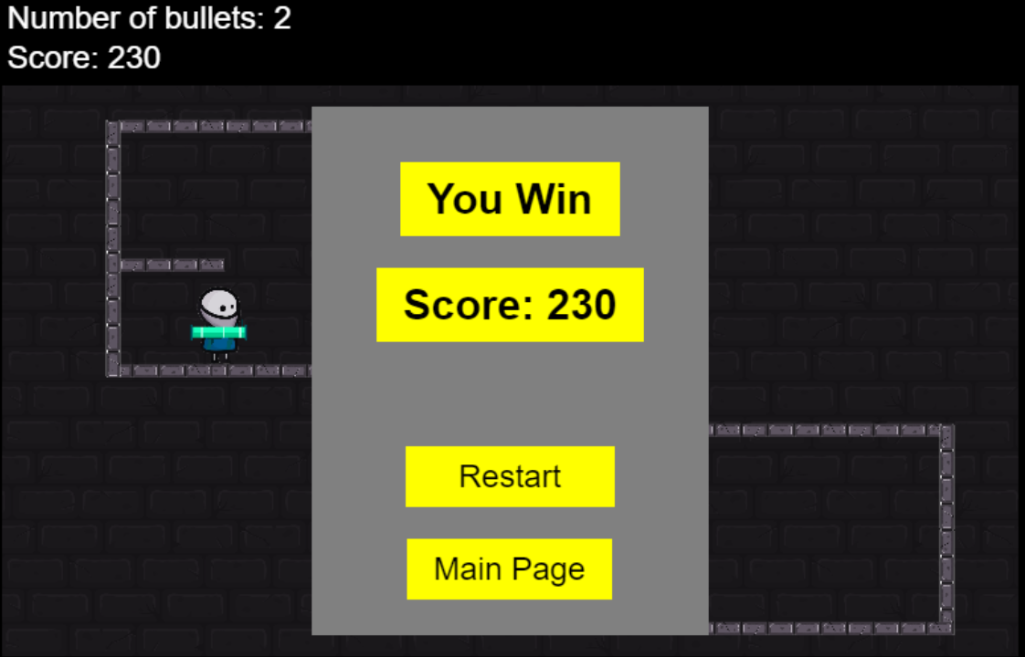

* If you did not defeat the entire enemy in five amount bullets then you lost the game.
* Choose “restart” if you want to play again.
* Choose “Main Page” to get back to start scene.

